Come for the Ride- Stay for the fishing and camping!

***AJ Jolley Equestrian Park***

***Northern Kentucky’s Oldest Horse Park***

11330 Flatwoods Rd, California, KY 41007

***Saturday May 12***

Ride out at 10am

Lunch provided by KyMidState Appaloosa Club.

Qualify for the Kentucky Appaloosa Owners Association Trail Ride Incentive Program

Hookups, Campsites, and Stalls available by reservation.

Call AJ Jolley Management at 859 547-3681 to reserve.

Special group discount for park entrance and trail fee- Ride limited to 30 riders. Call Jessi Williams at 859-802-5120 to sign up.

Coggins test results required by state law.

Come for the ride- stay for the camping and fishing!

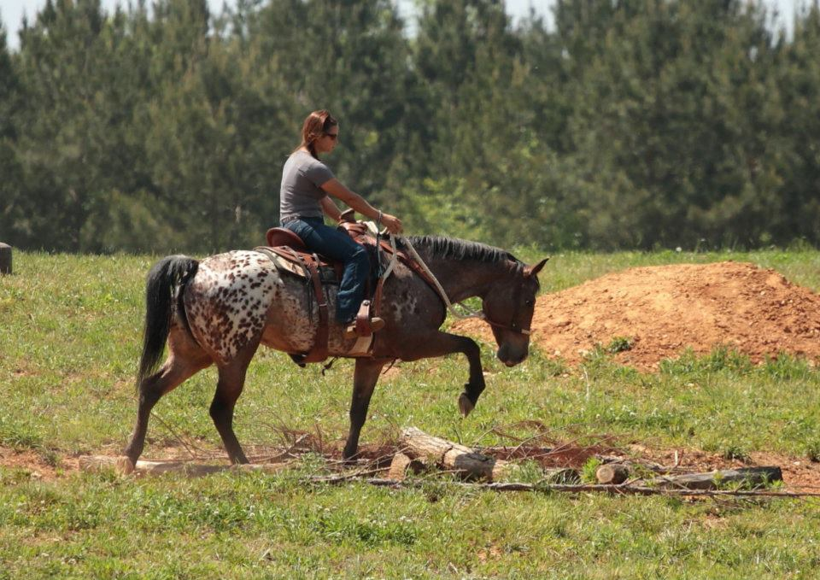

**Kentucky Appaloosa Owners Association**

**And The**

**KY-Mid State Appaloosa Club Presents**

**Season Kickoff Judged Trail Ride**

Under Kentucky law, a farm animal activity sponsor, farm animal professional, or other person does not have the duty to eliminate all risks of injury of participation in farm animal activities. There are inherent risks of injury that you voluntarily accept if you participate in farm animal activities."