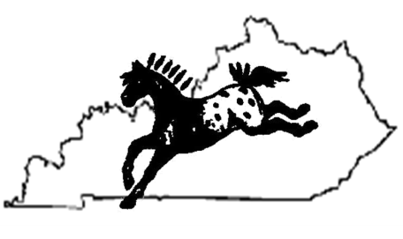

KY Mid-State

Appaloosa Horse Club

Sponsorship Form 2014

Appaloosa… … a Spot above the Rest

Sponsorship Packages

(Gifts of Any Size are Welcome and Appreciated)
Show Sponsorship $500
- Your business name/logo projected on the announcer’s stand throughout the day of the show (you provide digital image or the club will provide services to assist with artwork)
- A full page ad in the show program
- Sales booth at the show
- A link to your webpage from our site for one year
- A company or family representative presents a blue ribbon & receives a 5x7 photo of the presentation
- Your business information handed out during registration
- Officials sponsors are announced at the beginning, various times throughout, and at the end of the day of the KY Mid-State Appaloosa Horse Club 2014 horse show
Class Sponsorship $100
- A half page ad in the show program
- Your business or name posted on our website as a sponsor
- A company or family representative presents a blue ribbon in the sponsored class
- Your business information handed out during registration
- Class sponsors are announced at the beginning and end of the class they sponsor
- Your business name or name mentioned at the beginning and end of the day of the KY Mid-State Appaloosa Horse Club 2014 horse show

High Point Sponsorship $50
- A one quarter page ad in the show program
- Your business name or name mentioned at the high point class sponsored of the KY Mid-State Appaloosa Horse Club 2014 horse show
Program Ads
- Full page ad - $50
- Half page ad - $30
- Quarter page ad – 20$
- One eighth page ad - $10
- You provide digital image or the club will provide services to assist with artwork

Class Sponsors should choose a class from the
2014 Appaloosa Horse Club Show Flyer

Class Number: | _________
Class Name: | _____________________________________________________

If you have a website that you would like your ad to link to,
please provide the URL here:
________________________________________________________________________________________________
(example: www.yourwebsite.com)
Mail form and check payable to: | KY Mid-State ApHC  Paula Gatewood  4470 Jonesville Rd.,  Dry Ridge, KY 41035

For more information call or email:
Tonya Lindsay 502-514-1059 or
Email kymidstateaphc@yahoo.com
Visit us on the web at http://kymidstate.homestead.com/
Visit us on Facebook http://www.facebook.com/groups/265375576857302/

